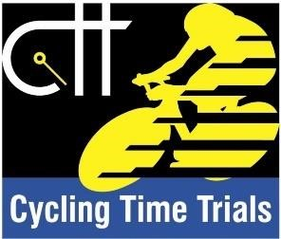
REMEMBER – You MUST sign-out after the event
Event:
Date:
I understand that the event will be held under the Rules and Regulations of Cycling Time Trials as shown in the current Handbook and I confirm that I am conversant with such Rules and Regulations and undertake to abide by them and to participate in the Drug Testing Programme whenever required to do so. I further declare that I am at present not under suspension by Cycling Time Trials or any organisation with which Cycling Time Trials have an agreement or (if so) such suspension will have expired by the date of the event. I agree to accept the decision of the promoter in all the matters concerning the event and my participation in it subject to such rights of appeal or review as may be provided for in the Rules and Regulations of Cycling Time Trials. I understand that the event is held wholly or in part on public or private property or the public highway and that I participate therein entirely at my own risk and that no liability whatever shall attach to the promoter, promoting club or any officials of the event, Cycling Time Trials or any club affiliated thereto or any member of such club for any injury loss or damage suffered by me in or by reason of the event however caused.

I CONFIRM THAT I HAVE READ ALL THE SAFETY INSTRUCTIONS CONTAINED IN THE START SHEET AND/OR DISPLAYED AT THE SIGNING-ON POINT. I
ALSO UNDERSTAND THAT ALL COMPETITORS IN CYCLING TIME TRIALS EVENTS MUST WEAR A HARDSHELL HELMET THAT MEETS AN INTERNATIONALLY ACCEPTED SAFETY STANDARD.
No. | Name (print) | Signature (sign in) | Signature (sign out)

